**Spring passage study protocol**

The Institute of Celestial Mechanics and Ephemeris Calculation (IMCCE) provides the exact date and time of the winter solstice each year. For 2020, the spring equinox will take place on 03/20/2020 at 03h 49m 36s UT, i.e. 4:49 am Paris time.

Or March 19, 2020 at 10:49 p.m. in Bogota

<https://www.imcce.fr/newsletter/docs/Equinoxe_printemps_1583_2999.pdf>

Before the onset of spring take the following points:

Preferably, check that there is no blockage of complex oscillations and if possible remove it, The study remains to be done to know if removing this blocking, does not also remove certain temporal reactions as indicated to me a colleague. But with RT 20, it should be better.

**It is possible that the observation can be made with a blocking of complex oscillations, but the quadrants will probably be different.**

Use a diametral Gold / silver test or, failing that, a Gold / silver stick that you present perpendicular to the skin, i.e. the Gold and Silver branches parallel to the skin (in contact or 2-3 cm)

To make it, you can find gold or silver sheets at a framer.

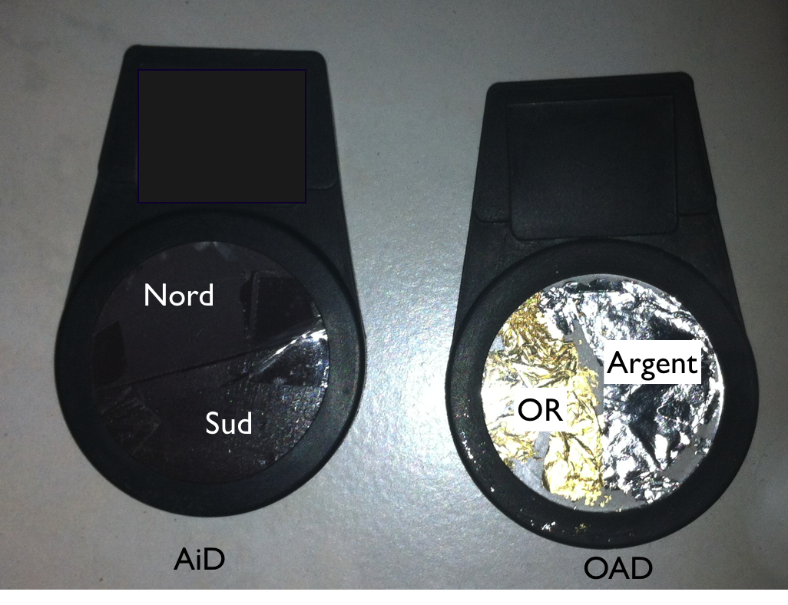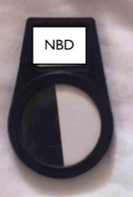

Use a diametral North / South magnet or, failing that, a North / South stick that you present perpendicular to the skin, i.e. the North and South branches parallel to the skin (in contact or 2-3 cm)

Optionally, also test the diametral Black / White

These tests can be done on yourself by taking the carotid pulse or on a person present at the time of the change of season.

Identify and record the cranial quadrants on which the RAC reacts.

Repeat the measurements before and after the season change time.

If you make the measurements at the time of the change you may be able to see that if it takes place, this change is made from one second to the next.

Return the result table (see below)

Date of measurement: Test used:

|  |  |  |  |  |
| --- | --- | --- | --- | --- |
| Put a cross in the corresponding boxes |  |  |  |  |
|  |  |  |  |  |
| right anterior quadrant QAD | RAQ |  |  |  |
| left anterior quadrant | LAQ |  |  |  |
| right posterior quadrant t | RPQ |  |  |  |
| left posterior quadrant | LPQ |  |  |  |
|  |  |  |  |  |
| **Before the change of season** |  |  |  |  |
|  |  |  |  |  |
| Complex oscillation blocking |  |  | Yes | No |
| Time of measurement |  |  |  |  |
|  | RAQ | LAQ | RPQ | LPQ |
| Test Or/argent |  |  |  |  |
|  |  |  |  |  |
| Test Nord/sud |  |  |  |  |
|  |  |  |  |  |
| Test Noir/blanc |  |  |  |  |
|  |  |  |  |  |
| **After the change of season** |  |  |  |  |
|  |  |  |  |  |
| Complex oscillation blocking |  |  | Yes | No |
| Time of measurement |  |  |  |  |
|  | RAQ | LAQ | RPQ | LPQ |
| Test Or/argent |  |  |  |  |
|  |  |  |  |  |
| Test Nord/sud |  |  |  |  |
|  |  |  |  |  |
| Test Noir/blanc |  |  |  |  |

**Annexes**

Reminder on time tests

These tests were developed to measure temporal variations. These are diametric tests, that is to say that they have the two polarities on the same face. Articles have been published on their use, but these tests still require further study, since the measurements are sensitive to oscillations, in particular to diathetic blockages and perhaps to variations in latitude. Therefore, no definitive conclusions can be drawn from it. In the techniques presented here, we will only use the hourly variation test which is the Black and White diametral test made with sheets of Canson paper. Half of the test is white and the other half is black. So this is the diametral black and white test.

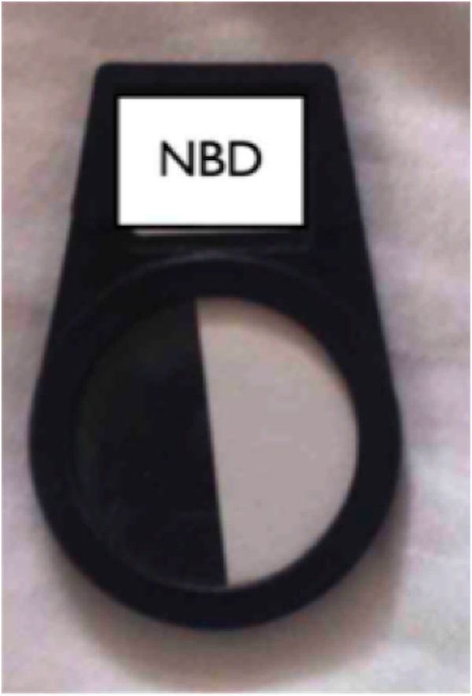

The diametral north / south magnet test measures the variations of the lunar phases while the gold / silver test measures the seasonal variations. We only present them here for those who would like to do research.

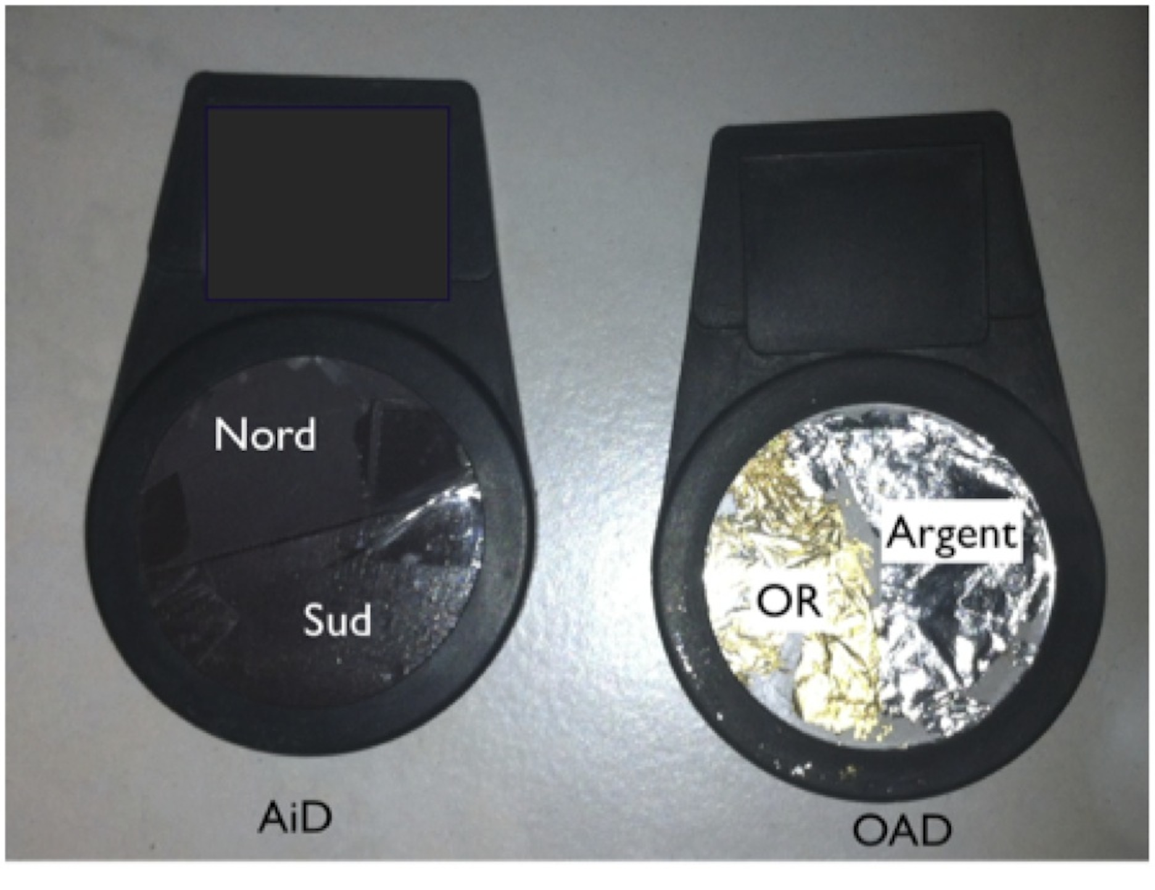

You can find gold and silver leaf at the framers.

**Self-observation**

It is possible to treat yourself or to do research tests on yourself by taking the carotid pulse either with the chicken or with two fingers.

We put the transfer regulator on his chest (or on a leg if we work seated) and we do the tests on the legs.

We then practice as with a patient by putting tests on oneself and studying transfers.

When developing some tests to create the RT 20, we realized that the reactions are different on the left leg and on the right leg. This must be taken into account if one is experimenting with certain tests on oneself. This is how we tested the associations of circular polarizers in order to find the configurations which made it possible to have the same results if we asked the tests on the right or on the left, on one side or the other.

For the measurements we make, the installation of the RT 20 in principle makes it possible not to have to take into account the side where the tests are placed.

**Time test equivalents**

In the renovated and simplified auriculomedicine book, I gave equivalents to the diametric tests. These tests are not enough

Aimant diamétral (AiD) : Leucine + Ac. Glutamique + Alanine + Tyrosine

Or/argent (OAD)= Méthionine + Valine + Acide aspartique + Isoleucine

Noir/blanc diamétral (NBD)= Thréonine + Cystéine + Asparagine + Sérine